# Question 2: Temperature Analysis

## Bringing the Data Together

The work begins by pulling in temperature readings from a stack of CSV files.   
Each file stands for one year, covering 1986 right through to 2005—about twenty years of records altogether.   
With the help of pandas, those yearly files are read and stitched into a single dataset.   
At the end of this step, the table holds month-by-month temperatures for all the reporting stations,   
giving a full picture of two decades of data in one place.  
  
  
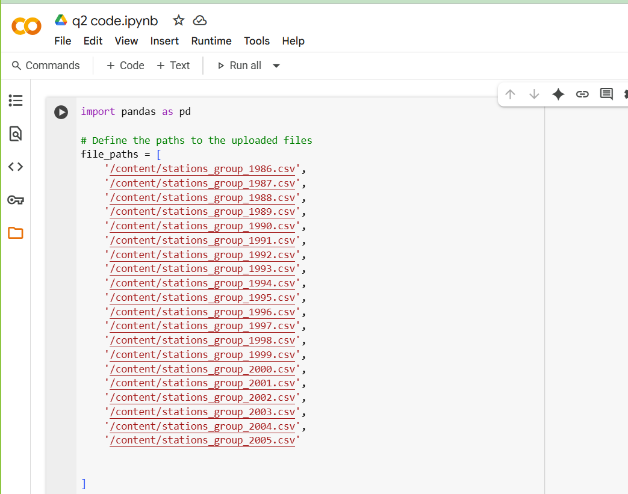

## Step 1: Seasonal Averages

The first job is to look at Australia’s seasons and see what the averages look like.   
For every season, the program picks out the months that belong to it, works out the mean for each station,   
and then combines those to get a national figure.

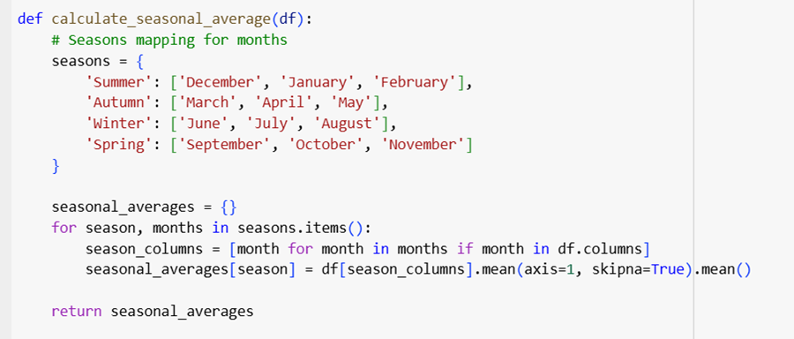  
  
To put it simply, the outcome is one number per season. For example, the results might say:  
- Summer 28.4 °C  
- Winter 12.1 °C  
  
It basically shows what the weather looks like on average in summer versus winter.

## Step 2: Checking Where the Climate Varies the Most

The next step is about spotting where the climate swings the most.   
The program checks every station, finds its highest and lowest monthly readings, and works out the difference. That difference is the station’s temperature range. Once all stations are checked, the program compares the ranges and points out the ones with the biggest gap.

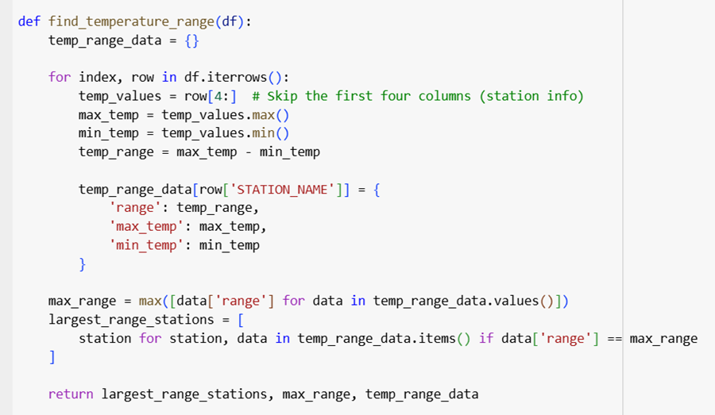  
Alongside the range, it also shows the actual maximum and minimum values.

For instance:  
Alice Springs Airport recorded one of the sharpest changes, with the hottest month climbing to about 45.2 °C and the coldest falling near 7.4 °C — a gap of 37.8 °C. Marble Bar showed a nearly identical pattern, ranging from 46.1 °C at the top end down to 8.3 °C at the bottom.

## Step 3: Temperature Stability

Here the focus shifts from extremes to steadiness.   
The code uses standard deviation to measure how much the monthly values at each station jump around. A smaller number means the climate hardly shifts, while a larger one shows that the station goes through strong seasonal changes.   
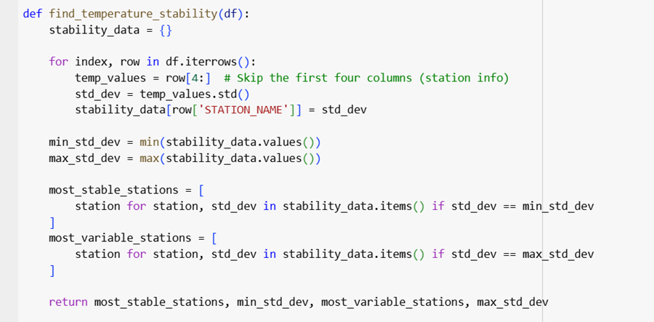  
So basically, this helps us see the contrast between predictable climates and the more extreme ones.

## Step 4: Pulling the Results Together

By now, the analysis makes it clear on three fronts:  
1. Typical temperature for each season across Australia  
2. The difference between hot and cold the greatest  
3. Where is the climate the most consistent, and where does it shift dramatically

  
Altogether, these findings give a broad view of Australia’s climate while also pointing out the unusual cases.

## Final Step: Storing the Results

The last thing the program does is save the findings into text files   
so they can be checked later without running the code again.

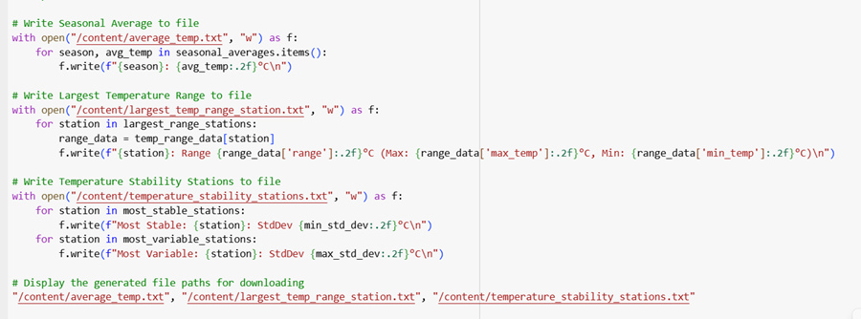  
The files include seasonal averages, the largest ranges, and the stability results.   
It also prints out the file paths to make them easy to locate.

# Outputs:

**Average Temperature: average_temp.txt**

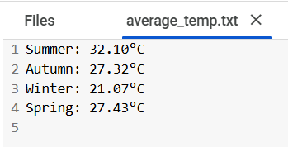 **Largest Temperature Range Station: largest_temp_range_station.txt**

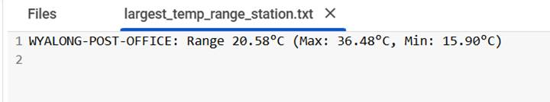 **Temperature Stability Stations: temperature_stability_stations.txt**

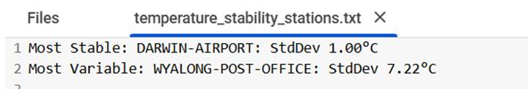

## Conclusion

All in all, the program takes twenty years of scattered weather records and turns them into a clear summary.   
It shows the average conditions for each season, highlights the locations with the sharpest contrasts,   
and points out the stations where the weather is either very steady or highly changeable.   
The results, written into simple text files, make it easy for anyone to see the bigger climate picture as well as the unusual cases.